Installing SUE
John Wensink
MIS445 - Statistics in Business Analytics
Colorado State University-Global Campus
Dr. Alin Tomoiaga
September 12, 2020

Installing SUE
For Week 1, this assignment was basic preparation and familiarization with SAS University Edition (SUE). The straightforward assignment asked for a screenshot and the answers to two questions.
Screenshot of SUE The CONTENTS Procedure
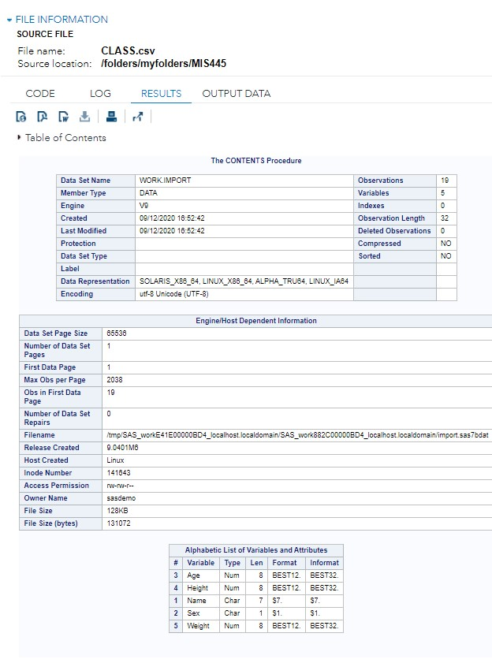
Answer the Following Questions
- How many observations and variables are there in the dataset?
There are 19 observations and 5 variables in the data set.
- What is the file size (in KB)?
The file size is 128KB.

